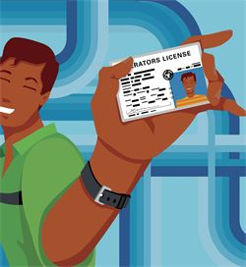
What is up with our I.D. requirements?

- Why do we ask for an I.D. every week?
We follow the rules of the Food Bank of Delaware and the USDA. Our partnership with them is how we get food to give you.
- Why do we ask for an I.D. every week?
We are permitted to give our food to anyone who is –
    - A Delaware resident and
    - In need, according to Food Bank guidelines
You are not required to show proof of need, but you are required to show proof of Delaware residency for everyone in your household.
- Why does everyone have to re-register EVERY January and EVERY July?
The income guidelines change, requiring that you recertify that you are eligible. Again, this is a Food Bank and USDA requirement. We just have to comply.
- Why won’t you accept expired licenses, Medicare, passports, and Social Security as I.D.?
The purpose of the I.D. is to show current Delaware residency. An expired license by definition doesn’t show that you’re a current resident. Medicare and Social Security are federal I.D.s, not Delaware. Your passport doesn’t include your residence. Also, you should carefully guard your Social Security number and not carry it with you unless you have to.

traer su credencial de identificación adecuada cada vez que venga
TODOS tienen que volver a registrarse cada 6 meses.
Traer la credencial de identificación adecuada de cada persona en su hogar en la primera visita en los meses de Enero y Julio.
La identificación debe mostrar su residencia actual en Delaware (Vea al reverso)
La persona que recoge los alimentos debe presentar su propia identificación en cada visita.
HORARIO DE DESPENSA
(SUJETO A CAMBIO SIN PREVIO AVISO)
1ro Jueves: A-D y familias NUEVAS
2do Jueves: E-L y familias NUEVAS
3ro Jueves: M-R y familias NUEVAS
4to Jueves: S-Z y familias NUEVAS
5^{to} Jueves: SOLO familias NUEVAS

Cedars Church of Christ
Food Pantry
ID Requirements*
* Required by the Food Bank of Delaware

- Bring your valid ID every time.
- Bring valid IDs for everyone in your household every January and July.

IDs we can ACCEPT
Adults (18 and older) Children (up to 17 only)
- CURRENT Delaware driver’s license OFFICIAL birth certificate
or non-driver ID Immunization record
- Delaware DOC card Delaware Medicaid card
- Delaware Social Services Recent Delaware report card
or Medicaid card Current Delaware school ID
- Business statement (recent electric bill,
for example, in that person’s name,
at Delaware address)
- Foreign consulate ID (if it includes
Delaware address)
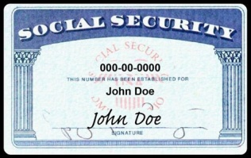
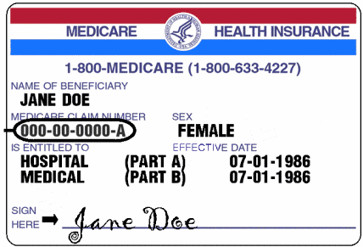
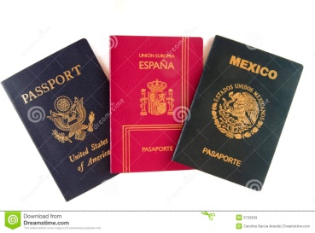
NO
- Social Security cards
- Medicare
- Passports
of Christ
Cedros Iglesia de Cristo

Cedars Church of Christ
Despensa de alimentos
Requisitos de identificación*
* Requerido por el banco de alimentos de DE

- Muestre su identificación válida en cada visita.
- Traiga la identificación válida de cada persona en su casa cada mes de Enero y Julio.

IDENTIFICACION ACEPTABLE

Adult0s (18 años o mayor) Niños (hasta 17 años)
- Licencia de conductor de Delaware Certificado oficial de nacimiento
- Tarjeta de identificación de no Cartilla de vacunación
conductor de Delaware Tarjeta de Medicaid de Delaware
- Tarjeta de identificación del Reporte escolar reciente
departamento de corrección de Identificación de escuela
Delaware actual
- Tarjeta de servicios sociales de Delaware
- Recibos o cobros de luz, teléfono, etc., que
muestre su nombre y dirección en Delaware

