Topic for Girls 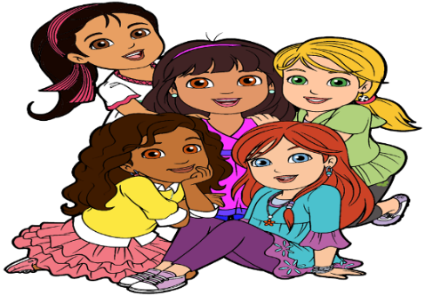date: 5-23-20
This Photo by Unknown Author is licensed under CC BY-NC
class: Our lesson will be on “Joy”
- For the class, please have 6 index cards and a marker available for our game.
- For our craft time, please have available 2 empty paper towel rolls, (you may color the outside of the roll before Saturday), White glue or paste, a piece of posterboard and safety scissors
BIBLE SCRIPTURE:
John 15:1-11

WHAT ACTION DO I TAKE?
- _______________________
- _______________________
- _______________________
- _______________________

MY REQUEST TO GOD

____________________________

WHAT I UNDERSTAND ABOUT IT
________________________________________________________________________________________________

